**Assignment - 1**

**Ans 1.**

1. Student relation : CREATE TABLE Student (sID INTEGER NOT NULL, sNAME TEXT NOT NULL, loginID TEXT NOT NULL, grade INTEGER NOT NULL, PRIMARY KEY (sID))
2. Course relation : CREATE TABLE Course (cID INTEGER NOT NULL, cNAME TEXT NOT NULL, credits INTEGER NOT NULL, grade INTEGER NOT NULL, CONSTRAINT fk_student FOREIGN KEY(grade) REFERENCES Student (grade))

**Ans 2.**

**1) 𝜋 Name(𝜎 Age>25(User)) =**

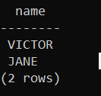

1. **𝜎 Id>2∨Age!=31(User) =**

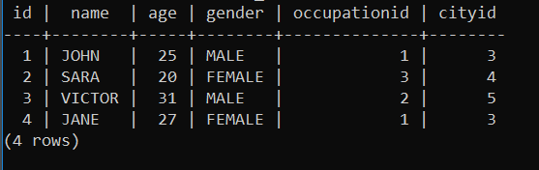

1. 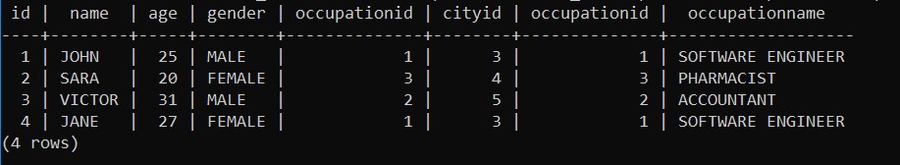**𝜎 User.OccupationId=Occupation.OccupationId(User X Occupation) =**
2. 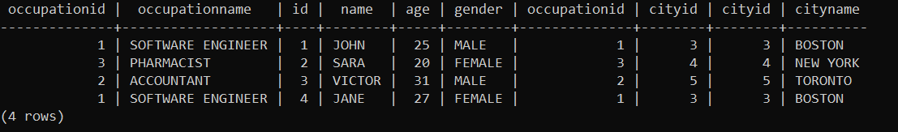**User ⋈ Occupation ⋈ City =**
3. **𝜋 Name,Gender(𝜎 CityName=”Boston”(User ⋈ City)) =**

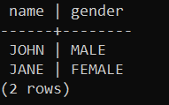

1. SELECT NAME FROM USER_T WHERE AGE > 25;
2. SELECT * FROM USER_T WHERE ID > 2 OR AGE != 31;
3. SELECT * FROM USER_T INNER JOIN Occupation on user_t.occupationid=occupation.occupationid;
4. SELECT * FROM OCCUPATION INNER JOIN (SELECT * FROM USER_T INNER JOIN CITY ON USER_T.CITYID=CITY.CITYID) AS IN1 ON OCCUPATION.OCCUPATIONID=IN1.OCCUPATIONID;
5. SELECT USER_T.NAME, USER_T.GENDER FROM USER_T INNER JOIN CITY ON USER_T.CITYID=CITY.CITYID WHERE CITY.CITYNAME LIKE 'BOSTON';

**Ans 3.** Referential integrity requires that a foreign key must have a matching primary key or it must be null. This constraint is specified between two tables (parent and child); it maintains the correspondence between rows in these tables. It means the reference from a row in one table to another table must be valid.

**Ans 4.**

Distributed Data Base Management Systems (D-DBMS) are the converging point of apparently contrasting areas: networking and Data Bases, representative of distribution and integration respectively.

Users should benefit from this new dimension when trying to make data processing architectures conform to managerial and organizational philosophies.

This paper is a technical overview of research and development in D-DMBS. In the first section, various architectures and design strategies are examined, followed by a description of functional layers. The second section is dedicated to Data Base design and mappings between levels of representations. The last section addresses Integrity control and Recovery.

**Ans 5.**

* Intraquery parallelism defines the execution of a single query in parallel on multiple processors and disks. Using intraquery parallelism is essential for speeding up long-running queries.

Interquery parallelism does not help in this function since each query is run sequentially.

To improve the situation, many DBMS vendors developed versions of their products that utilized intraquery parallelism.

* In interquery parallelism, different queries or transaction execute in parallel with one another.

This form of parallelism can increase transactions throughput. The response times of individual transactions are not faster than they would be if the transactions were run in isolation.

Thus, the primary use of interquery parallelism is to scale up a transaction processing system to support a more significant number of transactions per second.

Database vendors started to take advantage of parallel hardware architectures by implementing multiserver and multithreaded systems designed to handle a large number of client requests efficiently.

**Ans 6.** The slice operation performs a selection on one dimension of the given cube, resulting in a subcube. Reduces the dimensionality of the cubes. The dice operation defines a sub-cube by performing a selection on two or more dimensions.

**Ans 7.** OLTP and OLAP: The two terms look similar but refer to different kinds of systems. Online transaction processing (OLTP) captures, stores, and processes data from transactions in real time. Online analytical processing (OLAP) uses complex queries to analyze aggregated historical data from OLTP systems.

**Ans 8.**

1. Application Programmers

The users who write the application programs in programming languages (such as Java, C++, or Visual Basic) to interact with databases are called Application Programmer.

2. Database Administrators (DBA)

A person who manages the overall DBMS is called a database administrator or simply DBA.

3. End-Users

The end-users are those who interact with the database management system to perform different operations by using the different database commands such as insert, update, retrieve, and delete on the data, etc.

**Ans 9.**

A standalone function is created using the CREATE FUNCTION statement.

**Ans 10.**

Query Processing is the activity performed in extracting data from the database. In query processing, it takes various steps for fetching the data from the database. The steps involved are:

1) Parsing and translation

2) Optimization

1. 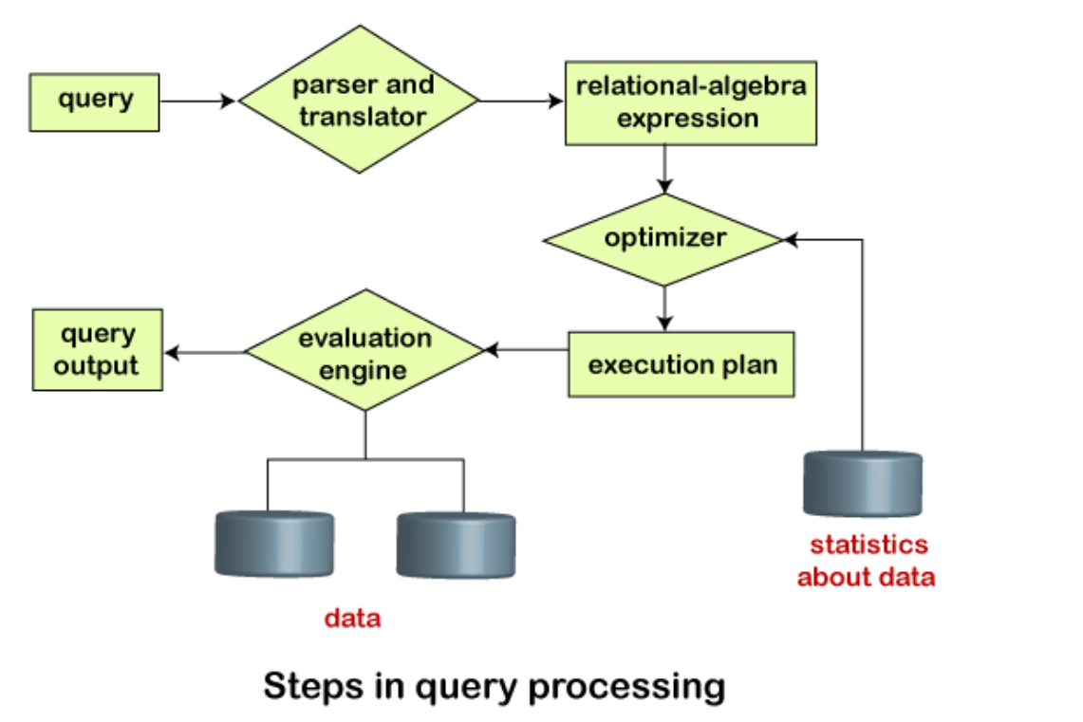Evaluation